CAD User’s Manual
Cal Poly San Luis Obispo

(DRAFT)

Introduction
This software suite contains four components. Each plays an important role in the simulation. Detailed descriptions and instructions are contained within this manual. To help you understand how each component interacts, they can be likened to parts of an automobile. The analogous parts are as follows:

CAD Simulator – Engine
The CAD Simulator runs the simulation, but only allows limited user interaction while running. Similarly, and automobile engine performs all of the work in propelling a car, but all you can do when you pop the hood of a running car is check the fluid levels.

Simulation Manager – Steering wheel, pedals and windshield.
The Simulation Manager connects to the CAD Simulator and allows a user to load simulation scripts and start and stop simulations. These functions are analogously the gas and brake pedals and steering wheel on a car. The Simulation Manager also allows the user to view all of the current simulation incidents, hence the windshield. There may only be one Simulation Manager(driver) connected to the CAD Simulator at a time. Finally, the Simulation Manager provides a CAD Client interface, since a driver can act as a passenger as well.

CAD Clients – Passengers
CAD Clients connect to the CAD Simulator and are allowed to view the current status of the simulation, much like looking out the side windows of the car. CAD Clients are not allowed to alter the flow of a simulation.
Paramics Communicator – CB Radio
The CAD Simulator connects to the Paramics Communicator and transmits an XML formatted file containing information about the current simulation. This is not necessary for a simulation to occur, but allows for the Paramics traffic simulator to correctly model the current simulation. Just as it may be nice to let other drivers in a caravan know your position over a radio, it’s not necessary.

CAD Simulator

The CAD Simulator is responsible for running a simulation. All other portions of the software are connected to this component during the simulation. A status window is displayed during this program’s operation. This window displays basic information about the current simulation and status of all connections.

1.1 Installation and Configuration

The Simulation Manager requires two files. These include an executable Java “.jar” file and a configuration properties file. These two files are named cadSimulator.jar and cadSimulator.properties, and are found in the <INSTALL_DIR>\Executable and <INSTALL_DIR>\Config directories respectively.
Prior to running the executable, you must modify the properties file. A sample file is shown below. The properties file contains the following information:

- Port that CAD Simulator binds for Socket communication
- Port that CAD Simulator binds RMI communication
- Exported RMI object name for communication to CAD Simulator
- Base location for audio files, relative to the <INSTALL_DIR>\Executable directory
- Script File for automatic simulation. (Optional)
- Communications Interval for the Paramics Communicator
- Host location of the Paramics Communicator
- Port the Paramics Communicator binds for RMI communication
- Host location of the CAD Database

CADSimulatorSocketPort = 4444
CADSimulatorRMIPort = 4445
CADSimulatorRMIObj = /coordinator
AudioFileLocation = file:../audio/
ScriptFile =
ParamicsCommInterval = 30
ParamicsCommHost = localhost
ParamicsCommPort = 4450
CADDatabaseLoc = localhost

The default information for this file is show above. You may modify the selected ports and exported object name, if necessary. If these values are changed, the configuration files for the CAD Client and Simulation Manager must be changed to reflect the new values. Changing the ports is not recommended. The base location of audio files will affect all simulation script files. Each script file contains the location of audio files, relative to this base location.

The ScriptFile line of the properties file allows you to automatically start a simulation. If a valid script file is listed, then the simulation will automatically begin when the CAD Simulator is started. Control may still be managed through the Simulation Manager. The value of this line is the location of the desired script file, relative to the CADSimulator.jar file. If there is an error in reading script file, an error message will appear, and the script file will not be loaded.

Must start db. When the properties file is correct, run the application. (create shortcut and run, or java –jar cadSimulator.jar

1.2 Running the Simulator

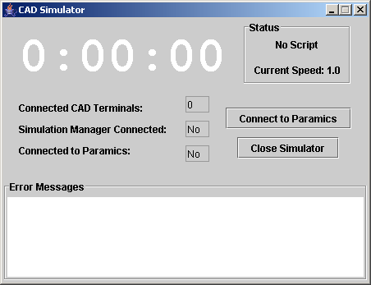
Figure 1 - CAD simulator status window.

When the CAD Simulator is started, the window shown in Figure 1 will appear. This window displays the following information
- Simulation status - Current simulation time, speed, and script status (“No Script,” “Started,” or “Stopped.”
- Current connections - How many CAD Terminals are connected and Simulation Manager and Paramics Communicator connection status.
- Error messages – Any errors that have occurred in communication from the CAD Simulator, and simulation script errors.

When the Simulation Manager is connected, the number of CAD Terminals connected value will include the CAD Client found on the CAD Client tab of the Simulator Manager (Section 2.7).
When loaded, the CAD Simulator will not be connected to the Paramics Communicator. To connect, ensure the Paramics Communicator is running, and press the Connect to Paramics button. If the connection is successful, the Paramics Connected: status will be changed to Yes and the button will now say Disconnect from Paramics. Pressing this button will then disconnect. If the connection is not successful, an error will appear in the Error Messages window.
To close the CAD Simulator and exit the program, first close any CAD Clients and Simulation Manager. Then press the Close Simulator button, or press the ‘X’ in the upper right corner of the window. If CAD Clients or Simulation Manager are still open when the simulator is shut down, they will display an error the next time they attempt to access the CAD Simulator.

2.0 Simulation Manager

The Simulation Manager allows control over a simulation. The features include:
  - Loading a script file
  - Starting, stopping, and resetting a simulation
  - Managing simulation incidents during a simulation
  - Viewing the CAD log history
  - Sending CAD routed messages to CAD terminals
  - Sending commands to the Paramics Traffic Simulator

2.1 Installation and Configuration

The Simulation Manager requires two files. An executable Java “.jar” file and a configuration properties file. These two files are named simManager.jar and simManager.properties, and are found in the <INSTALL_DIR>\Executable and <INSTALL_DIR>\Config directories respectively.
Prior to running the executable, you must modify the properties file. A sample file is shown below. The properties file contains the following information:

- Host location for CAD Simulator
- Port that CAD Simulator has bound RMI communication
- Exported RMI object name for communication to CAD Simulator
- Port that CAD Simulator has bound for Socket communication

CADSimulatorHost = localhost
CADSimulatorRMIPort = 4445
CADSimulatorRMIObj = /coordinator
CADSimulatorSocketPort = 4444

Modify this file to contain the correct host location for the CAD Simulator (IP address or domain name). The remaining values in this file will match those in the properties file for the CAD Simulator (see Section 1.1).
When the properties file is correct, run the application. (create shortcut and run, or java –jar simManager.jar

2.2 User Interface Overview

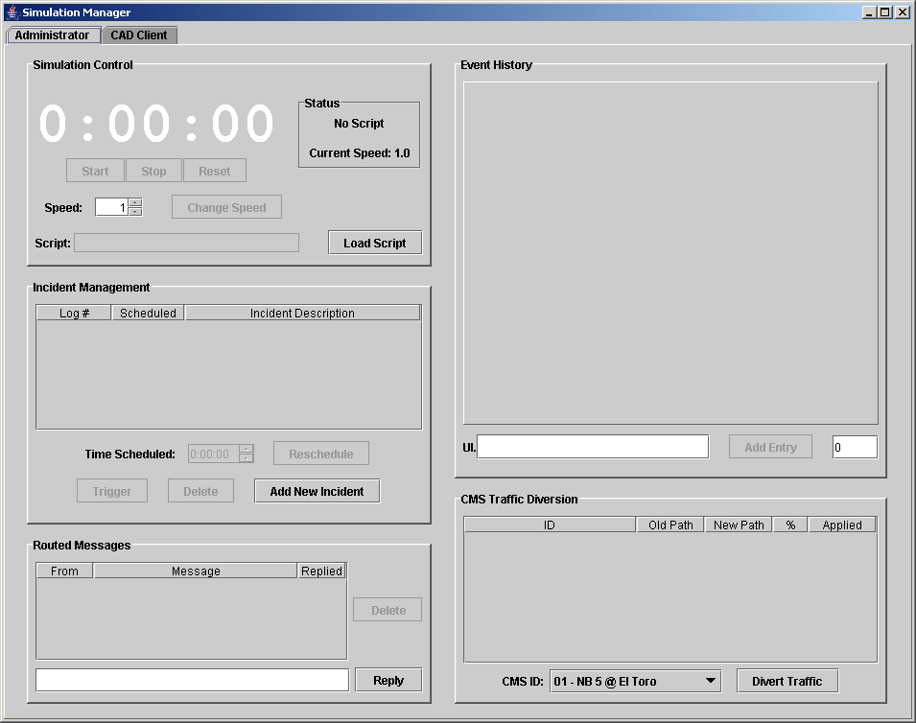
Figure 2 - Main simulation manager window.

** note ** The following sections assume a simulation has not begun when then Simulation Manager is being loaded. For information on what would be different when a simulation has started…. See section …

2.3 Simulation Control

This portion of the Simulation Manager Interface provides the basic controls for the simulation. These controls include starting, stopping, resetting, and changing the speed of a simulation. The current time in the simulation is displayed, along with the current status. This status includes whether a script has been loaded, and if so, whether the simulation is currently running of stopped. The current speed is also displayed. Loading script files into the simulation is done from this Simulation Control area as well. The following sections explain these functionalities.

2.3.1 Basic Simulation Control

When the Simulation Manager is loaded, the Simulation Control area appears as seen in Figure 3. The buttons will not be enabled until incidents have been loaded into the simulation. This is done by either loading a script(Section 2.3.2 2) or by adding individual incidents (Section 2.5.2). Once an incident has been added to the simulation, the Start, Reset, and Change Speed buttons will be enabled.

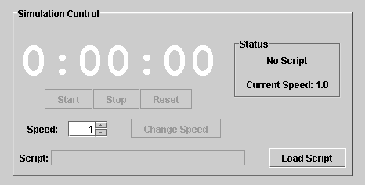
Figure 3 – Simulation Control.

To start a simulation, press the Start button. The Simulation Status area will show that the simulation has started and the simulation timer will begin counting. While a simulation is running, you may not press the Start, Reset, or Load Script buttons. The Stop button will be enabled when a simulation begins. Pressing the Stop button will pause the simulation. Pressing Start will resume the simulation at its current location. Pressing Reset will reset the simulation timer and all loaded incidents. Figure 4 shows the Simulation Control area during a running simulation.
At any point, the simulation speed may be changed. Pressing the up or down arrows in the Speed combo box increases or decreases the speed by increments of .25. Press the Change Speed button to apply the new speed. The timer will reflect the updated speed, and the Simulation Status area will display the new speed.

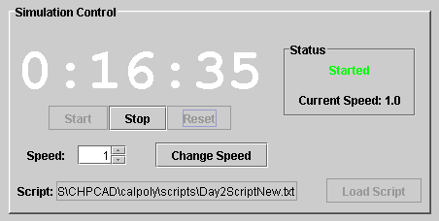
Figure 4 - Simulation control during simulation.

2.3.2 Loading a Script File

A script file is used to load a list of incidents into the simulation. Each script file contains a list of incident declarations, which contain CAD log events, along with an associated audio file and time that the event occurs. To load a script file, push the Load Script button. A file chooser window will appear, as seen in Figure 5. Browse to the location of the script file, select it, and then press Open.

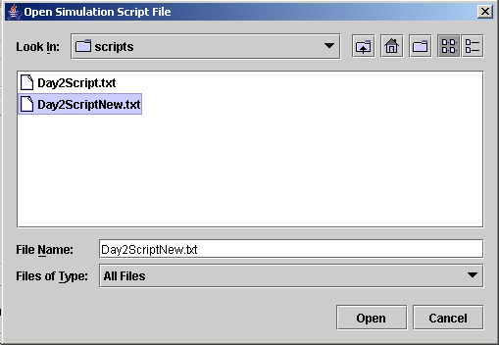
Figure 5 - Load script file chooser.

This script file is sent to the CAD Simulator, where the file is parsed, and the simulation incidents are created. If an error is encountered, a dialog box will appear notifying you of the error. When an error occurs, all script information is removed from the simulation to avoid confusion. If the script file is opened successfully, the loaded script’s path will appear in the Script text area, and the Status area will be updated, as seen in Figure 6.

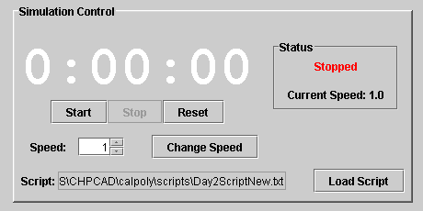
Figure 6 - Simulation Control after loading script.

2.5 Incident Management & Event History

The Incident Management area of the Simulation Manager allows you to manage the incidents that have been loaded into the simulation. The Event History area displays incident events that have occurred in the current simulation.

2.5.1 Manage Loaded Incidents

When the Simulation Manager is first loaded there are no incidents in the current simulation and then Incident Management area will appear as seen in Figure 7. Only the Add New Incident button will be activated until a script is loaded or individual incidents are added. Once the simulation has at least one incident, all of the buttons and input areas will be enabled.

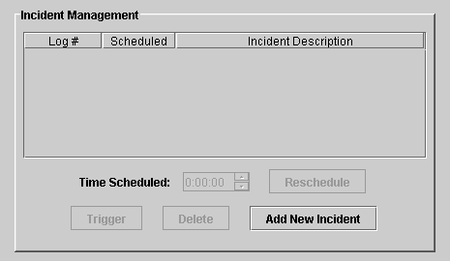
Figure 7 - Initial incident management.

Figure 8 shows the Incident Management area after a script has been loaded. The incident table displays the log number, scheduled time, and description for each incident that has been loaded. When an incident’s scheduled time has been reached in the simulation, “Enqueued” will appear in the Scheduled column. When the first audio file for that incident has finished playing, “Occurred” will appear.
Only one incident may be selected at a time from the incident table. The Trigger, Delete, and Reschedule buttons all affect the incident that is selected, explained below. The Time Scheduled combo box shows the time that the selected incident is scheduled to occur.

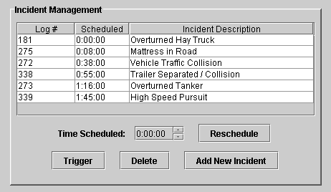
Figure 8 - Incident management with scripted incidents.

- Trigger – Pressing this button will cause the selected incident to occur immediately, instead of at its scheduled time.
- Delete – Pressing this button will remove the incident from the simulation entirely. The incident will not be restored if the Reset button is pushed from the Simulation Control area.
- Reschedule – Pressing this button will set the scheduled time for the selected incident to the time that is currently in the Time Scheduled combo box. You may not schedule the incident for a time that has already passed. The up and down arrows may be clicked or held to increase or decrease the scheduled time by increments of 10 seconds. The updated time scheduled will appear in the incident table.

2.5.2 Add New Incidents

You may also add individual incidents to the simulation. To do this, press the Add New Incident button. A file chooser window will appear. Browse to the selected file, and press “Open.” If there is an error in opening the script file, a dialog box will appear. If the file is opened successfully, the following dialog window will appear. This dialog window shows the incidents that were found within the loaded file. The log number, description, and incident length are shown.

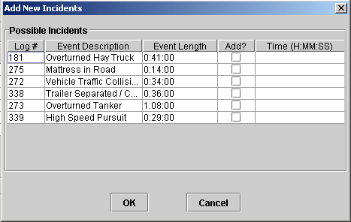
Figure 9 - Add new incidents dialog.

To add an incident to the simulation, click the Add check box and then enter the time you want to schedule the event for in the Time column. This entered time must be typed in the format of H:MM:SS. After entering the time, press enter, or click else where on the table to apply the new time into the table column. After selecting the desired incidents and entering their times, press the OK button. If an invalid time was entered, the error will be displayed in red below the table, shown in Figure 10. If the incidents were successfully added to the simulation, this dialog window will close and the new incidents will appear in the incidents table.


Figure 10- Add new incidents dialog with error message.

2.5.3 Event History Table

Each incident in the current simulation has a corresponding tab in the Event History portion of the Simulation Manager. As a simulation proceeds, each event that occurs will appear on the corresponding incident tab. As seen in Figure 11, the table displays each event’s origin, time occurred, and the CAD command that generated the event. Incident updates can originate from three locations, shown in the following table.

Origin | CAD SCRIPT | SIM MANAGER | CAD TERMINAL
Description | Update from script file | Update from Simulation Manager | Update from a CAD Terminal

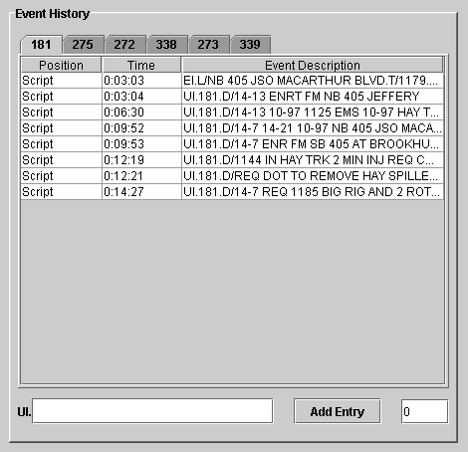y
Figure 11 - Event history table.

Updates from the Simulation Manager are entered in the text area found at the bottom of the Event History area. Updates are added to an incident and may be routed to a specific CAD Terminal. To add an update to an incident, enter your desired text in the UI. text area. Then enter the location to route the update in the ???? field. A value of 0 will not route the message to a specific terminal. Any other value will route add the update to the incident and route an Incident Inquiry(Section ??) screen to the CAD Terminal with that position number.

When an update is received from a CAD Terminal the update will immediately appear in the corresponding Event History incident tab. If that tabbed window is not currently active, the tab for that incident will turn red. When the tab is selected it will turn gray again.

2.6 Routed Messages

During a simulation, CAD terminals may send CAD routed messages to the Simulation Manager. Received messages are displayed in the Routed Messages table, shown in Figure 12. For each message, the sending CAD position and message are shown.

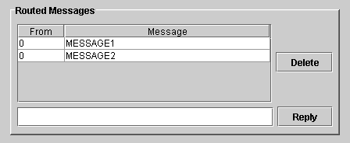
Figure 12 - Routed messages table.
Only one message may be selected in the table at a time. To reply to a message, select it in the table, type in your response, and press the Reply button. The reply is sent to the correct CAD terminal and the Replied column will contain a Yes. To remove a message without replying, select it and press the Delete button.

*The Simulation Manager’s CAD position is 0.

2.7 CMS Traffic Diversion

During a simulation, the students will apply messages to Changeable Message Signs through the ATMS. In order to correctly model the affect of these messages, the CMS Traffic Diversion section (Figure ?) of the Simulation Manager allows you to apply traffic diversions from individual signs.

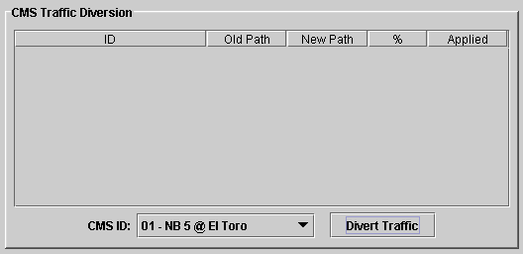

This section will not initially contain any data. The pull down list to the left of the Divert Traffic button contains all possible signs that can be assigned a diversion. Choose a sign, and then press the Divert Traffic button. A pop-up window will appear for this message sign, as seen in figure ?.

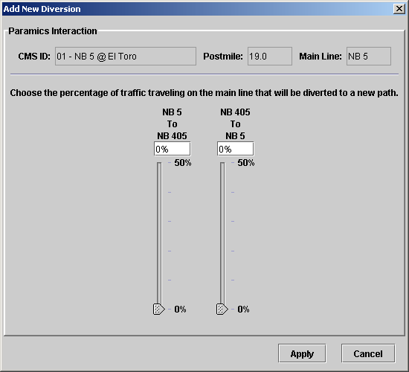

The sliders on this window allow you to divert a percentage of traffic from its original path to a new path. As is seen at the top of the window, the traffic is initially traveling on a Main Line, “NB 5” in our example. The path diversions are displayed above each slider. The top route is the path which vehicles are planning to take, and the bottom route is the new path which will be assigned. In our example, the first slider will divert traffic that would have originally stayed on “NB 5” to “NB 405.” The second slider diverts traffic that would have originally merged onto “NB 405” back onto “NB 5.” Each slider has a maximum diversion, as previously determined and entered in the CAD Database. When the desired diversions are set on the sliders, press the Apply button. Pressing the Cancel button will undo all changes to the sliders.

After a diversion has been set for a message sign, the diversion table on the Simulation Manager will display this new information. For our example, diversions of 14% and 37% were applied to Sign “01 – NB 5 @ El Toro.” (Figure ?)

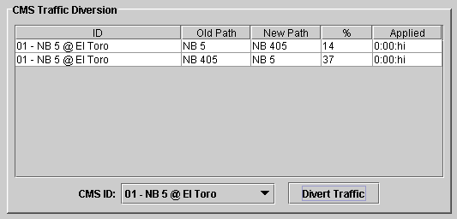

To add more diversions, select a new sign and follow the process above. To modify diversions for a current sign, choose that sign, and press the Divert Traffic button. The same dialog window will appear, but it will reflect the current diversions. To cancel a diversion, move the slider to 0%. The diversion will be removed from the simulation and will no longer appear in the diversion table. After modifying diversions, press Apply. Pressing Cancel will return all diversions to their original values and close the window.

2.8 CAD Tab

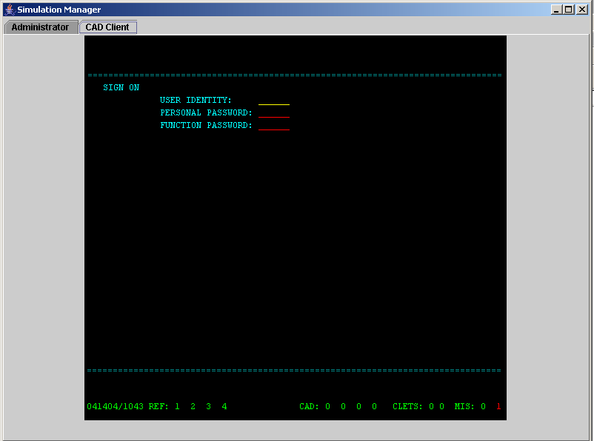
Figure 13 - CAD client tab.

The CAD Client allows you to access the simulation through the CAD Terminal interface that the other student CAD Clients use. During a simulation, this CAD will operate as a normal CAD workstation would. The “REF:” window numbers will highlight when an update is found for that window. CAD routed messages will appear in the fourth position of the “CAD:” footer area of the screen. The following section explains the provided CAD commands.

CAD Commands

- II – Incident Inquiry. Enter II.LOG# to view log information
- UI – Update Incident. Follow normal syntax. UI.D/TEXT may be typed to update the log on the current screen. UI.LOG#.D/TEXT may be typed to update any current log.
- SA – Incident Summary. Window shows all current incidents in the log.
- IB – Incident Board. Not currently being used, but it’s there.
- EB – Enter Bulletin. Adds a bulletin to the bulletin board.
- TO – Routed Messages. Follow Syntax of “TO.POS.M/TEXT”. To route a message to the simulation manager, use POS equal to 0.

Key Mappings

The following table shows the actions taken by the CAD for a specific keystroke.

Key | Action | Key | Action
F1 | Command Line Transmit | Shift-F12 | Clear Screen
F8 | Next Queue | Home | Page Up
F9 | Delete Queue | End | Page Down
F10 | Previous Queue | Page Up | Cycle Screens
Shift-F11 | Clear Command Line | Page Down | Refresh

Script File Creation

Shown below is a sample script file with one incident. The format of the incident is shown below the example. Each element in the script file is separated by a ‘~’. The Incident Log Number is used to uniquely identify each incident in the CAD software. A ‘<>’ marks the end of an incident declaration.
Example:
Trailer Separated / Collision~
0:55:00~
338~
0:00:00~EI.L/WB 91 JWO HARBOR BLVD.T/1179.D/9-6 ENR FM 91~33801.wav~21~NEW;30;LANE_BREAKDOWN;1;2;3~
0:04:00~UI.338.D/10-97 11-82 BIG RIG AND VEH BLKNG #3-4~33802.wav~36~!~<>

Format:
Incident Name~
Incident Start Time~
Incident Log Number~
Event Start Time ~ Event Info ~ Audio File ~ Audio File Delay Time(sec) ~ Paramics Info ~
Event Start Time ~ Event Info ~ Audio File ~ Audio File Delay Time(sec) ~ Paramics Info ~
...<>

Note: Event Start Time is relative to Incident Start Time

! is used for an empty string… when no audio file, or paramics info

